Jake Sylvestre

Chapter 39: The Stalemated 70’s

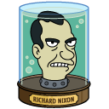

* Richard Nixon
  + Suspicious...Paranoid...Why?
  + Resented Democratic Party
  + Issues: Vietnam
    - **Vietnamization**
      * Withdrawal of 540,000 troops in south vietnam
      * Train south vietnamese military
      * My Lai Massacre 1968
        + leak->investigation->14 soldiers charged with murder
        + Lt. William Cowlie
        + 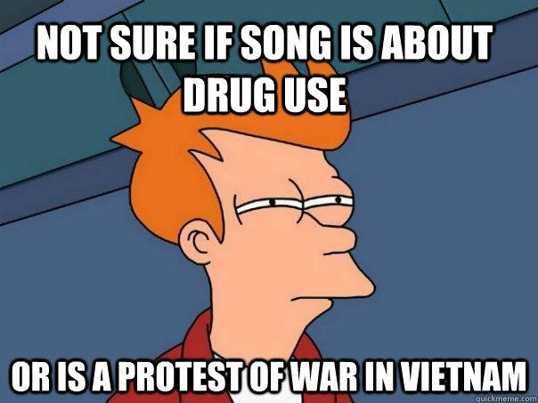
    - **Nixon’s Detente**
      * Relaxed tensions with Russia/Chine
      * prelude to exit from Vietnam
      * Led to
        + **US/Russian Food Deal**
        + ABM (Anti-Ballistic missile treaty)
        + SALT (Strategic Arms Limitation Talks)
    - **Fallout from Cambodia**
      * Nixon Invasion w/out Congressional Consultation
      * Student Reaction to Cambodia
        + Lent State University

4 Dead

* + - * + Jackson State College

2 Dead

* + - * More Americans Turning Against the War
      * Cambodia Aftermath
        + More Americans turning against war
        + Period of draftability shortened
* Passage of the 26th amendment
  + lowered voting age to 18
  + The Warren Court
    - SC Justice Earl Warren
    - Judicial Activism
    - Concern for the Individual
    - Nixon doesn’t like them
  + 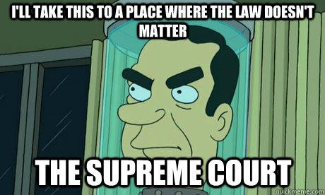
    - Cases
      * Engel v. Vitale
        + A non-denominational prayer at the beginning of the day violates first amendment Establishment of Religion
      * School Dist. Abington Township v. Schempp
        + Yes 8-1 it’s a violation to require to say prayers before school
      * Gideon v. Wainwright
        + The sixth amendment's right to counsel in criminal cases extends to felony defendants in state courts
        + **9-0**
        + The constitution protects the right of marital privacy against state restrictions on a couple’s ability to be counseled in use of contraceptives
      * Escobedo v. Illinois
        + Escobedo was denied the right to counsel as guaranteed by the sixth amendment
        + 5-4 right to counsel
        + Miranda V. Arizona

The police practice of interrogating individuals without notifying them of their protection against self-incrimination violates the 5th amendment



* + - * + NIXON HATES SUPREME COURT
      * Nixons Court
        + Appoints Warren Burger Chief Justice
        + Total of 4 conservative justices
* War Powers Act
  + November 1973 (secret bombing of Cambodia)
  + President must report to Congress within 48 hours after committing troops to foreign land
  + End of the Draft!
* Watergate Scandal
  + 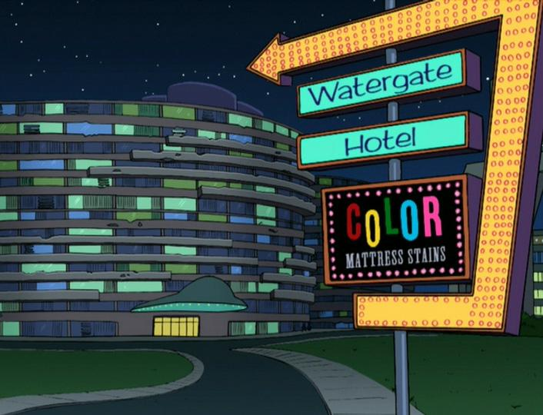
  + Effort to plant “bugging” devices (Dem. HQ)
  + Republican Committee for Re-Election of President (CREEP)
  + VP Agnew Resigns (Ford Replaces)
* Watergate
  + Nixon adamantly denies (refuses to hand over tapes)
  + 9-0 executive privilege does not apply
  + Prove wrongdoing by nixon
  + Impeachment is Inevitable
  + August 8th, 1974: Nixon Resigns (Ford and Pardon)
* Vietnam Ends
  + Ford...No Congressional Support
  + Cease-Fire
  + All GI’s out of nam’ in 60 days
* Feminism Victories:
  + 1972: Title IX
    - protects from discrimination against pregnant woman
    - Rights for sexually harassed women
    - Equal opportunity for athletics for females
  + ERA: 3 states short of passing
  + Reed v. Reed (1971)
    - Did the Idaho Probate Code violate the Equal Protection Clause of the Fourteenth Amendment
  + Frontiero v. Richardson (1973)
    - Federal law, requiring different qualification criteria for male and female military spousal dependency, unconstitutionally discriminate against women
  + Roe v. Wade (1973)
    - The constitution embraces a woman’s right to terminate her pregnancy by abortion
* Iran Hostage Crisis
  + November 1979: Anti-American militants
  + Demands: Ship back the Shah
  + Iranian Revolution gaining momentum
  + 444 Days in capativity
* Iraq
  + Sidam Whosane takes over Iraq
  + Quate